CMS – External Source Services

Deployment Guide

Revision History
Author | Revision Number | Date
cyberjag | 1.0 | 05.31.2013

1. Deployment Instructions 3
2. Organization of Submission 3
3. Application Setup 3
3.1 Software Stack 3
3.2 Database Setup 3
3.3 Install Guvnor 3
3.4 Websphere Setup 6
3.5 Build Scripts Setup 8
3.6 Configuration Files 8
4. Deployment Instructions 8
5. Starting 9
6. Verification 9
7. Resource Contact List 11

Deployment Instructions

Organization of Submission

- cms-external-sources - the enterprise archive contents
- services – contains the EJB implementation
- tests – contains the web service tests
- db – contains the database creation scripts and oracle driver
- startup-war – contains the CXF services and startup servlet

Application Setup

Software Stack

    - Oracle 11g

- Please download from Oracle and install per product documentation.

    - Websphere 8.5

- Download the software from IBM and install per product documentation. This guide refers to the application server installation folder as <appserver.dir>

Database Setup

Run the script db/mita3.sql in your oracle client.

Websphere Setup

Note: You may run into out of memory errors using the default heap size, please adjust it to at least 1GB (less may work, but this was tested using 1GB), you may check the websphere documentation or follow the below guide to setting the heap size, please restart websphere after setting a new value.

http://www.mkyong.com/websphere/how-to-increase-websphere-jvm-memory/

You need to setup 1 datasource and SSL key management for SAM. The next steps assume that you are logged in to WAS8.5 console

- To setup authentication (db user), from the left navigation go to Security > Global Security >
- Click on “Java Authentication and Authorization Service” it should show several options, click on “J2C authentication data”
- Click “New” and Enter the database user information

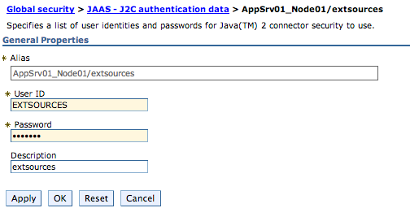

- Apply and Save the configuration changes

- Navigate to Resources > JDBC > JDBC Providers, Select you node and click on “New”
- Enter the database type (oracle), provider type (Oracle JDBC Driver), Implementation Type (XA data source). Click Next.
- (Optional) Enter the oracle driver jar and click on “Apply”
- Enter the location of the jar specified then click “Next”
- Review the settings and click “Finish”

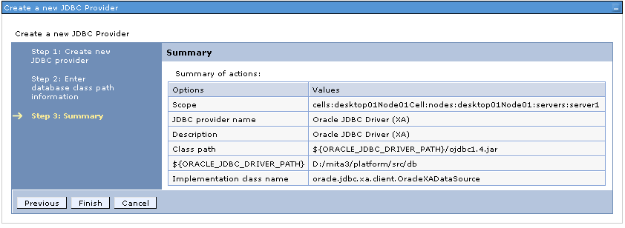

- Navigate to Resources > JDBC > Data sources, Click on “New”
- Enter the data source name (ExternalSourcesDS) and the JNDI name (ExternalSourcesDS)
- Click Next, Select the XA datasource provider created earlier
- Click Next, Enter the database URL. Leave the rest as default.
- Click Next, Select the J2C authentication data created earlier for “Authentication alias for XA recovery”, “Component-managed authentication alias” and “Container-managed authentication alias”. Leave the rest as default.
- Click On Next, Finish then Save. Test your data source.

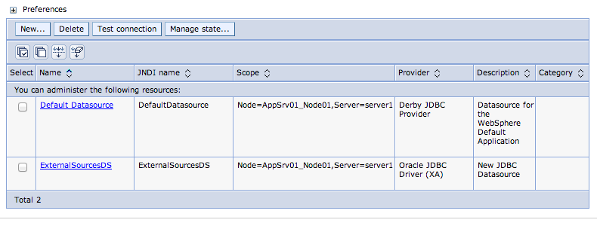
- Navigate to Resources > Security > SSL Certificate and key management, Click on “Manage endpoint security configurations”
- Click on the Outbound Node which needs SSL certificate (AppSrv01_Node01)
- Click on Related Items > Key stores and certificates
- Click on NodeDefaultTrustStore
- Click on Additional Properties > Signer Certificates, Click “Add”
- Enter Alias as gw.sam.gov_cert and File name as the location of the SSL certificate from SAM (The current certificate is provided in the docs folder).
- Use Data Type as Binary DER data and Click “Apply”

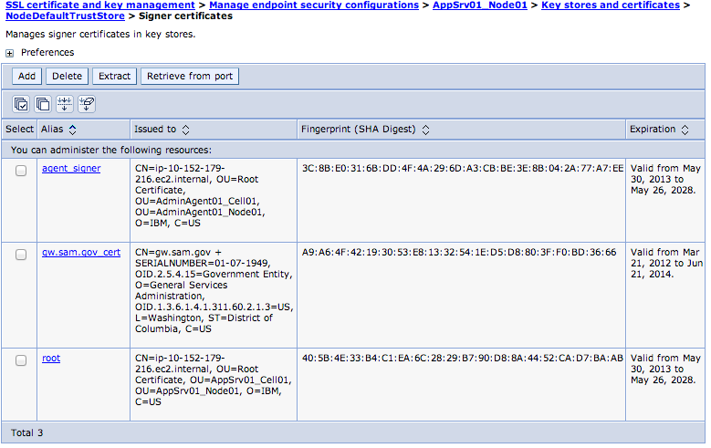

Build Scripts Setup

    - application/build.xml

The following targets are available:

build-core Builds the core archive
build-ejb Builds the EJB archive
build-war Builds the startup web archive
clean Removes all generated files
dist Creates EAR distribution artifact
deploy-netstudy-mocks Deploys a mock version of the NET Study web service
netstudy-generate-client Regenerates the NET Study client
test Runs the Web service tests
undeploy-netstudy-mocks Undeploys the mock version of the NET Study web service

    - application/build.properties

// this is the only property relevant to websphere deployment
was.home – location of websphere 8.5

Configuration Files
    - cms-external-sources/services/src/main/resources/META-INF/ejb-jar.xml

Contains configuration needed by each of the services

Entry | Description | Beans
mita/config/URL | URL for the external source | All *DAOBean classes
mita/config/disciplineURL | Discipline List external URL | ChiropracticLicenseDAOBean
mita/config/loginURL | External Login URL | NursingLicenseDAOBean
mita/config/username | External Login User | NursingLicenseDAOBean
mita/config/password | External Login Password | NursingLicenseDAOBean
mita/config/verificationURL | Verification URL | OIGDAOBean
mita/config/exclusionURL | Exclusion type list URL | OIGDAOBean
mita/config/providerTypeId | The id of the provider type | All subclasses of BaseProviderScreeningDAO
mita/config/netStudyWebServiceUrl | The net study web service url
mita/config/denialStatusesConfig | The denial statuses for net study
mita/config/inputDirectory | The input directory used for file processing | DeathMasterSchedulerBean  PECOSSchedulerBean
mita/config/archiveDirectory | The archive directory used for file processing | DeathMasterSchedulerBean and PECOSSchedulerBean
mita/config/intervalDuration | The interval duration to run for batches | DeathMasterSchedulerBean and PECOSSchedulerBean

    - test.properties

Contains the test related settings

Entry | Description
testFolder | Location of the test SOAP requests
testLogDir | Location where actual responses are logged
java.naming.provider.url | JNDI URL
java.naming.factory.url.pkgs | JNDI factory URL package
java.naming.factory.initial | JNDI initial context factory
StatsTrackerServiceJNDI | JNDI name for Stats tracker
MarriageAndFamilyTherapyLicenseServiceEndPoint | WS Endpoint for MarriageAndFamilyTherapyLicenseService
PhysicalTherapyLicenseServiceEndPoint | WS Endpoint for PhysicalTherapyLicenseService
OptometryLicenseServiceEndPoint | WS Endpoint for OptometryLicenseService
PharmacyLicenseServiceEndPoint | WS Endpoint for PharmacyLicenseService
MedicalPracticeLicenseServiceEndPoint | WS Endpoint for MedicalPracticeLicenseService
ChiropracticLicenseServiceEndPoint | WS Endpoint for ChiropracticLicenseService
DieteticsAndNutritionPracticeLicenseServiceEndPoint | WS Endpoint for DieteticsAndNutritionPracticeLicenseService
DentistryLicenseServiceEndPoint | WS Endpoint for DentistryLicenseService
NursingLicenseServiceEndPoint | WS Endpoint for NursingLicenseService
BBHTLicenseServiceEndPoint | WS Endpoint for BBHTLicenseService
EPLSServiceEndPoint | WS Endpoint for EPLSService
OIGServiceEndPoint | WS Endpoint for OIGService
BusinessLienSystemServiceEndPoint | WS Endpoint for BusinessLienSystemService
NurseAnesthetistsLicenseServiceEndPoint | WS Endpoint for NurseAnesthetistsLicenseService
HealthOccupationsProgramCredentialServiceEndPoint | WS Endpoint for HealthOccupationsProgramCredentialService
PodiatricMedicineLicenseServiceEndPoint | WS Endpoint for PodiatricMedicineLicenseService
SocialWorkLicenseServiceEndPoint | WS Endpoint for SocialWorkLicenseService
MedicaidCertifiedProvidersServiceEndPoint | WS Endpoint for MedicaidCertifiedProvidersService
AccreditedBirthCentersLicenseServiceEndPoint | WS Endpoint for AccreditedBirthCentersLicenseService
HospitalLicensingServiceEndPoint | WS Endpoint for HospitalLicensingService
CommunityMentalHealthCenterLicensingServiceEndPoint | WS Endpoint for CommunityMentalHealthCenterLicensingService
HospiceLicensingServiceEndPoint | WS Endpoint for HospiceLicensingService
PrivateDutyNursingGroupLicensingServiceEndPoint | WS Endpoint for PrivateDutyNursingGroupLicensingService
PublicHealthNursingOrganizationLicensingServiceEndPoint | WS Endpoint for PublicHealthNursingOrganizationLicensingService
RenalDialysisFreeStandingLicensingServiceEndPoint | WS Endpoint for RenalDialysisFreeStandingLicensingService
PharmacyLicensingServiceEndPoint | WS Endpoint for PharmacyLicensingService
ChemicalDependencyProgramServiceEndPoint | WS Endpoint for ChemicalDependencyProgramService
ChildrensResidentialServiceEndPoint | WS Endpoint for ChildrensResidentialService
DayTrainingAndHabilitationCenterServiceEndPoint | WS Endpoint for DayTrainingAndHabilitationCenterService
IntensiveResidentialTreatmentServiceServiceEndPoint | WS Endpoint for IntensiveResidentialTreatmentServiceService
PersonsWithDevelopmentalDisabilitiesIntermediateCareFacilityServiceEndPoint | WS Endpoint for PersonsWithDevelopmentalDisabilitiesIntermediateCareFacilityService

Deployment Instructions

- Setup oracle and websphere per instructions above
- Execute “ant dist”, this will create the archive under the folder “build”
- Log in to the WAS console
- Navigate to Applications > Application Types > Websphere enterprise applications
- Click “Install” and upload the generated ear file from by ant script
- Click Next. Accept All Defaults for all the screens
- Click On Finish, wait for installation to complete, then click “Save”.
- Select the application and click “Start”, the status should turn green

Starting

The app is started through the websphere console (see Deployment Instructions).

Verification
The wsdl generated can be verified like this:

- Open http://ec2-50-16-65-237.compute-1.amazonaws.com:9080/cms-ext/ws/BBHTLicenseService?wsdl

Resource Contact List

Name | Resource Email
Jerrish Varghese | jerrishissac@gmail.com

